NEWTON COUNTY REQUEST FOR PROPOSAL COVER SHEET

RFP#2018-8 TREC HOUSE INSPECTOR FOR CDBG DISASTER RECOVERY FUNDS (2015 AND 2016 FLOODING EVENTS/DR-4223, DR-4245, & DR-4266 DISASTER DECLARATIONS)

The enclosed REQUEST FOR PROPOSAL (RFP) and accompanying specifications and statement of work are for your convenience in submitting an offer for the enclosed referenced products and/or services for NEWTON COUNTY.

Offers shall be received no later than:

FRIDAY, NOVEMBER 9, 2018 AT 4:30 P.M., LOCAL TIME
PLEASE MARK ENVELOPE: “REQUEST FOR STATEMENT OF PROPOSALS FOR #2018-8 TREC HOUSE INSPECTOR FOR CDBG DISASTER RECOVERY FUNDS (2015 AND 2016 FLOODING EVENT/DR-4223, DR-4245, & DR-4266 DISASTER DECLARATIONS)

Respondent shall sign and date the offer as requested on each page. Offers, which are not signed and dated in this manner, may be rejected.
DELIVER OFFER TO:
PHYSICAL ADDRESS FOR COURIERS & HAND DELIVERIES **MAILING ADDRESS SANDRA K. DUCKWORTH (SEE NOTE BELOW)
NEWTON COUNTY CLERK
115 COURT STREET
P.O. BOX 454
NEWTON, TEXAS 75966

NEWTON COUNTY appreciates your time and effort in preparing this offer. Please note that all offers must be received at the designated location by the deadline shown. Offers received after the deadline will not be considered for the award of the Contract and shall be considered void and unacceptable.

**US Postal Service mailing address
The U.S. mail may not deliver to the physical address shown above. Respondents who prefer to use the U.S. mail may submit their offers using the U.S. Postal Service mailing address shown below.

HOWEVER, packages delivered by the U.S. Postal Service to the Newton County mailing address are subject to delays that may cause a response to be rejected due to missing a solicitation receipt deadline.
Respondents using the U.S. mail should take this possible delay into account when using the U.S. mail. MAILING ADDRESS:
SANDRA K. DUCKWORTH
NEWTON COUNTY CLERK
P.O. BOX 454
NEWTON, TEXAS 75966

Initials____

NEWTON COUNTY is very conscious and extremely appreciative of the time and effort you have expended to submit an offer. We would appreciate it if you would indicate on any “No Offer” response, any requirement of this RFP which may have influenced your decision to “No Offer”. If your response to this RFP is a “No Offer” response, please complete the Statement of No Offer in this RFP package and submit.

Any prospective bidder/respondent desiring any explanation or interpretation of the solicitation must make a written request which must be received by the Auditor’s Office at least five (5) business days prior to the scheduled time for the bid/offer opening. The request must be addressed to Elizabeth Holloway, Newton County Auditor, P. O. Box 296, Newton, Texas 75966, emailed to elizabeth.holloway@co.newton.tx.us, or faxed to (409)379-5755. Any information given to a prospective bidder/respondent concerning this solicitation will be furnished promptly to all other known prospective bidders/respondents as a written amendment/addendum to the solicitation. Newton County reserves the right to accept or reject any or all bids/offers as it deems in its best interest and to waive any formalities.
It is the Bidder/Respondent’s responsibility to verify the issuance of Addenda in regard to this Bid/Offer. All Addenda shall be submitted to all known bidders/respondents and shall be posted on the Newton County Website www.co.newton.tx.us, under “CDBG DR-4266 Information” and “CDBG DR-4223 & 4245 Information”. Newton County shall not be responsible for failed internet connections or power interruptions.

All required Bid/Offer documents shown on the Package Checklist including any Addenda Receipt Forms which may have been issued must be included in a sealed envelope marked with the bidder’s company name, the Bid/Offer name, number and due date.

Elizabeth Holloway
Elizabeth Holloway, Newton County Auditor

Initials____

NEWTON COUNTY BIDDER/RESPONDENT CERTIFICATION

RFP#2018-8 TREC HOUSE INSPECTOR FOR CDBG DISASTER RECOVERY FUNDS (2015 AND 2016 FLOODING EVENTS/DR-4223, DR-4245, &DR-4266 DISASTER DECLARATIONS)

LEGAL NAME OF CONTRACTING COMPANY

FEDERAL I.D. # (Company or Corporation) SOCIAL SECURITY # (Individual)

TELEPHONE NUMBER |  | FACSIMILE NUMBER
CONTACT PERSON |  | TITLE
COMPLETE MAILING ADDRESS |  | CITY & STATE |  |  | ZIP CODE
COMPLETE STREET ADDRESS |  | CITY & STATE |  |  | ZIP CODE
EMAIL ADDRESS

CERTIFICATION
By my signature hereon, I certify that the Goods and/or Services that I propose to furnish will meet or exceed every specification contained herein, and that I have read each and every page of the Specifications/Statement of Work, other requirements, as well as, the Standard Terms & Conditions and Offer Sheet. Further, I agree that if my offer is accepted, I shall perform as required in these Contract documents. I am aware that, once accepted by Newton County, my offer becomes a binding Contract in accordance with the provisions herein of the aforementioned Contract documents, and that I will not be permitted to attempt enforcement of any other Contract or Contract provisions.

SIGNATURE DATE

Typewritten or Printed Name Title

Initials____

NEWTON COUNTY
CONTRACT SHEET

THE STATE OF TEXAS

COUNTY OF NEWTON

This memorandum of agreement made and entered into on the day of , 2018, by and between Newton County in the State of Texas (hereinafter designated County), acting herein by County Judge Paul Price, by virtue of an order of Newton County Commissioners’ Court, and (hereinafter designated Contractor).

WITNESSETH:

The Contractor and the County agree that the Instructions to Respondents, Specifications/Statement of Work, Standard Terms & Conditions, and all other requirements herein for RFP#2018-8 TREC HOUSE INSPECTOR FOR CDBG DISASTER RECOVERY FUNDS (2015 AND 2016 FLOODING EVENTS/DR-4223, DR-4245, & DR-4266 DISASTER DECLARATIONS) as stated in the Request for Proposal Package Checklist hereto attached and made a part hereof, together with the bond (when required), and shall constitute the full agreement and Contract between parties and for furnishing the items set out and described; the County agrees to pay the prices stipulated in the accepted offer.

It is further agreed that this Contract shall not become binding or effective until signed by the parties hereto and a purchase order authorizing the items desired has been issued.

Executed at Newton, Texas this day of 2018.

By:
Paul Price, Newton County Judge

By:
Signature of Contractor

By:
Printed Name and Title

Initials____

REQUEST FOR PROPOSAL PACKAGE CHECKLIST

RFP#2018-8 TREC HOUSE INSPECTOR FOR CDBG DISASTER RECOVERY FUNDS (2015 AND 2016 FLOODING EVENTS/DR-4223, DR-4245, &DR-4266 DISASTER DECLARATIONS)

Items checked below represent components, which comprise this bid/offer package. If the item IS NOT checked, it is NOT APPLICABLE to this bid/offer. Bidders are asked to review the package to be sure that all applicable parts are included. If any portion of the package is missing, notify the Newton County Purchasing Department immediately.
It is the bidder's responsibility to be thoroughly familiar with all requirements and specifications. Be sure you understand the following before you return your bid/offer packet. Failure to provide these items may result in rejection of bid/offer.
- X Cover Sheet
- X Bidder Certification -Must be signed (IN INK) by an authorized representative of the respondent having the authority to bind the firm into a contract.
- X Contract Sheet - Must be signed (IN INK) by an authorized representative of the respondent having the authority to bind the firm into a contract (TO BE SUBMITTED BY VENDOR UPON AWARD)
- X Package Checklist

X Instructions to Respondents
- X Scope of Work - See Exhibit A
- X Offer Sheet - Must be signed (IN INK) by an authorized representative of the respondent having the authority to bind the firm into a contract.
- X Statement of No Offer

X Standard Terms and Conditions
- X Special Requirements

X Bidder/Respondent’s Affirmation
Company name, identifying information and signature (IN INK).

X SDNs/Blocked Persons Affirmation
- X Insurance Requirements

X Conflict of Interest Questionnaire – Form CIQ
- X Certificate of Interested Parties Form 1295 (TO BE SUBMITTED BY VENDOR UPON AWARD)
- X Vendor Data Sheet & W-9 Form (Respondent information and W-9 Form must be completed and returned with offer)
- X Return Label
- X Attachments: The documents marked below are hereby attached and made a part of this package.

Initials____
NEWTON COUNTY INSTRUCTIONS TO RESPONDENTS

RFP#2018-8 TREC HOUSE INSPECTOR FOR CDBG DISASTER RECOVERY FUNDS (2015 AND 2016 FLOODING EVENTS/DR-4223, DR-4245, &DR-4266 DISASTER DECLARATIONS)

The following requirements and specifications shall be in addition to the other requirements contained herein and shall supersede the other requirements where applicable.

1.0 THE CONTRACT:
The Contract consists of the Instructions to Respondents, Scope of Work, Standard Terms & Conditions, as well as all other documents included in the Request for Proposal Number 17-8 as stated in the Request for Proposal Package checklist and any other specifications, as well as addenda issued prior to execution of the Contract, other documents listed in the Contract, and modifications issued after execution of the Contract. The Contract represents the entire and integrated agreement between the parties hereto and supersedes prior negotiations, representations, or agreements, either written or oral. The Contract may only be amended or modified under the terms of this Contract. Newton County may make partial or complete awards to one or more vendors (if applicable) whichever is in the best interest of the County.

2.0 PROJECT DESCRIPTION

Newton County is seeking proposals for the following:

Providers will help the Newton County fulfill State and Federal Community Development Block Grant Disaster Recovery (“CDBG-DR”) statutory responsibilities related to recovery in connection with any federally declared disaster. Providers will assist Newton County in completing a licensed TREC Property Inspection of completed CDBG-DR qualified housing projects. Respondents must be qualified to provide Inspection services for housing projects in compliance with TREC standards and regulations. These services must also be performed in compliance with the U.S. Department of Housing and Urban Development (“HUD”) and guidelines issued by the GLO.

The contract for TREC Inspection services is contingent upon the receipt of CDBG-DR funds and, if no such funds are awarded, the contract shall terminate.

PROPOSAL REQUIREMENTS

The proposal includes instructions to respondents, specifications and contract documents. It is the responsibility of each Respondent before submitting a proposal to examine the contract documents thoroughly.

One (1) original and four (4) copies shall be submitted which will include all documents associated with the request for proposal. Each marked page of the response sheets must be manually signed or initialed by an officer of the company having the authority to bind the company in a Contract.

Newton County prefers that the original response be unbound, and the four (4) copies be bound in a three (3) ring or plastic comb binder. Each submittal shall be marked as “Original” or “Copy”.

Complete responses shall be sealed in an envelope or box for delivery to the Newton County Clerk per instructions herein. All documents included in the response and the outside of the envelope and/or box must be labeled with the respondent's name and the RFP number which corresponds to this proposal.

Initials____

Each response shall be organized to conform to the RFP sequence and format. Respondent should provide a response for each and every portion of the RFP. Responses should be carefully considered by the respondent as they are critical to the evaluation process. Evaluation will consider the adequacy, accuracy and completeness of responses. While Newton County appreciates a brief straightforward concise proposal, the respondent must fully understand that the evaluation is based on the information provided. Any ambiguous and equivocal statements may be construed against the respondent.

Where appropriate, your response may consist of phrases such as “understood” “agreed”, or “no exception”. Any omissions shall be assumed to be “No Exceptions”. Any ambiguous and equivocal statements may be construed against the respondent.

Provider must note any exceptions to the statements, specifications or requirements stated in the proposal documents. These exceptions must be provided at the time of the RFP submission in order to be considered. Exceptions to the Standard Terms and Conditions and Special Requirements may be placed in an Appendix labeled “Exceptions.”

Each respondent shall submit completed standard submission forms provided in this Request for Proposal. Newton County shall have the right to take such steps as it deems necessary to determine the ability of the respondent to perform its obligations under the Contract, and the respondent shall furnish Newton County all such information and data for this purpose as it may request. Newton County reserves the right to reject any offer where an investigation of the available data pertaining to the qualifications of a respondent is not to the satisfaction of Newton County.

4.0 CONTRACT AWARD / EVALUATION PROCESS

An evaluation committee will examine all responses to this Request for Proposals. Responses that do not conform to the instructions given or that do not address all the questions and services specified may be eliminated from consideration.

Newton County may initiate discussions with respondents. Additional information will be accepted during this period from respondents who responded to the original request. Respondents may NOT initiate discussions. Newton County expects to conduct discussions with respondent personnel authorized to enter into contractual obligations.

Newton County shall rank responses in accordance with the Evaluation Criteria listed in Section 6.0 and will review proposal content and its conformance to requirements. Following an initial evaluation, the evaluation team may recommend award without further discussion with one or more respondents or may conduct discussions and interviews with top-ranked responsible respondent(s).

During the discussion / interview and negotiations, the evaluation team may allow the respondent(s) to submit a best and final offer. Final offers shall be evaluated on the same criteria used in the first evaluation.

Newton County reserves the right to reject any and all proposals and is not obligated to award a contract pursuant to this request for proposal.

EVALUATION CRITERIA

The criteria used to evaluate the proposals shall be:

Experience / Background with CDBG-DR and
Federally Funded projects 30 Points
Experience / Background with TREC Inspections 15 Points
Work Performance 15 Points
Capacity to Perform 30 Points
Proposed Cost 10 Points

Initials____

PROPOSAL SCORING CRITERIA

The following information will be used by the County in the selection of the vendor to provide the work as stated in Section 2.0 Description.

    - Experience / Background with CDBG-DR and Federally Funded projects – Related experience and background with specific project type (Infrastructure / Rental Housing / Non-Rental Housing).

    - Experience / Background with TREC inspections – Related experience and background with specific project type (Rental Housing / Non-Rental Housing).

    - Work Performance –Submits requests to client / GLO in a timely manner; responds to client / GLO in a timely manner; past client / GLO projects completed on schedule; work product is consistently of high quality with low level of errors; past client / GLO projects have low level of monitoring findings / concerns; manages projects within budgetary constraints.

    - Capacity to Perform –Qualifications of Professional Administrators / Experience of Staff; present and projected workloads; quality of proposal / work plan; demonstrated understanding of scope of the CDBG program.

    - Proposed Cost – Proposed cost within project delivery

6.0 REQUESTS FOR CLARIFICATIONS

Any prospective respondent desiring any explanation or interpretation of the proposal must make a written request which must be received by the Auditor’s Office at least five (5) business days prior to the scheduled time for the proposal submission. The request must be addressed to Elizabeth Holloway, at the address listed below, or faxed to (409)379-3359.

Newton County Auditor’s Office
Attn: Elizabeth Holloway
P.O. Box 296
Newton, Texas 75966

Respondents may also email requests for clarification to: elizabeth.holloway@co.newton.tx.us.

Questions and answers will be posted on the Newton County website: www.co.newton.tx,us.

Initials____

7.0 AWARD LETTER / NOTICE TO PROCEED

After the award has been made in Commissioners’ Court, an award letter will be sent to the vendor with information on how to submit any required documentation needed to finalize the award. Once all required insurance and other applicable forms have been submitted to the Auditor’s Office, the County Judge will contact the awarded vendor and set up the project kick-off meeting, if applicable.

8.0 MODIFICATIONS PRIOR TO SUBMISSION

Prior to submission of proposals, an offer may be modified or withdrawn by an appropriate document duly executed and delivered to the place where proposals are to be submitted prior to the date and time for the submission of proposals.

9.0 DISCLOSURE OF CERTAIN RELATIONSHIP

Texas Local Government Code chapter 176 requires that any vendor or person who enters or seeks to enter into a contract with a local governmental entity (including any agent of such person or vendor) disclose in the Questionnaire Form CIQ the vendor or person’s employment, affiliation, business relationship, family relationship or provision of gifts that might cause a conflict of interest with a local governmental entity. By law, this questionnaire must be completed and filed with the records administrator of Newton County no later than the seventh business day after the date the person engages or communicates with Newton County or becomes aware of facts that require the completion of the questionnaire pursuant to Texas Local Government Code section 176.006.

A person commits an offense if the person knowingly violations Texas Local Government Code section
176.006. An offense under this section is a Class C misdemeanor.

A copy of House Bill 23 which amended the Texas Local Government Code Chapter 176 is available at: http://www.capitol.state.tx.us/tlodocs/84R/billtext/html/HB00023F.HTM
Texas Local Government Code Chapter 176 can be found
here: http://www.statutes.legis.state.tx.us/Docs/LG/htm/LG.176.htm

Questionnaire Form CIQ is included in this bid/offer

By submitting a response to this request, the vendor or person represents compliance with the requirements of Texas Local Government Code chapter 176. If required, completed forms should be sent to:

Newton County Clerk
P.O. Box 454
Newton, TX 75966

10.0 CERTIFICATE OF INTERESTED PARTIES

Effective January 1, 2016, all contracts and contract amendments, extensions, or renewals executed by the Commissioners Court will require the completion of Form 1295 “Certificate of Interested Parties” pursuant to Government Code § 2252.908. Form 1295 must be completed by awarded vendor at time of signed contract submission.

Form 1295 and definitions are included in this bid/offer for your information.

Initials____

HISTORICALLY UNDERUTILIZED BUSINESSES (HUB’s)

Historically Underutilized Businesses (HUB’s) are encouraged to participate in the bid/RFP processes. Although Newton County does not certify HUB vendors, Newton County recognizes the
certifications of other governmental entities. If you are certified by a government entity, please include your certificate in your bid submittal.

Per Code of Federal Regulations, Title 2, § 200.321, “Contracting with small and minority businesses, women's business enterprises, and labor surplus area firms”, if awarded vendor is a prime contractor and subcontractors are to be let by prime contractor, the following affirmative steps are required of the prime contractor:

    - Placing qualified small and minority businesses and women's business enterprises on solicitation lists;

    - Assuring that small and minority businesses, and women's business enterprises are solicited whenever they are potential sources;

    - Dividing total requirements, when economically feasible, into smaller tasks or quantities to permit maximum participation by small and minority businesses, and women's business enterprises;

    - Establishing delivery schedules, where the requirement permits, which encourage participation by small and minority businesses, and women's business enterprises;

    - Using the services and assistance, as appropriate, of such organizations as the Small Business Administration and the Minority Business Development Agency of the Department of Commerce.

12.0 SYSTEM FOR AWARD MANAGEMENT (SAM)

Prior to bid submittal, bidders/respondents must register with the System for Award Management (SAM) or have an active registration with SAM. Registration is free.

The System for Award Management (SAM) is the official registration required prior to bidding on a contract with any federal government agency, including local governments who receive federal funds.

Registering online is accomplished on the SAM website at www.sam.gov.

13.0 CONTRACT TERM

Award will be made to the best firm meeting our specifications and evaluation criteria. The contract term shall begin upon award and continue until completion of the project, and in accordance with the timeline established in the Federal Register.

14.0 INSURANCE REQUIREMENTS

Contractor shall furnish certificates of insurance to County evidencing compliance with the insurance requirements hereof for the duration of the project. Certificates shall indicate name of Contractor, name of insurance company, policy number, term of coverage and limits of coverage.

Insurance shall be placed with insurers having an A.M. Best’s rating of no less than A. Such insurance must be issued by a casualty company authorized to do business in the State of Texas, and in standard form approved by the Board of Insurance Commissioners of the State of Texas, with coverage provisions insuring the public from loss or damage that may arise to any person or property by reason of services rendered by Contractor.

Initials____
Insurance required herein shall be maintained in full force and effect during the life of this contract and shall be issued on an occurrence basis. Contractor shall require that any and all subcontractors that are not protected under the Contractor’s own insurance policies take and maintain insurance of the same nature and in the same amounts as required of Contractor and provide written proof of such insurance to Contractor. Proof of renewed/replacement coverage shall be provided upon expiration, termination, or cancellation of any policy. Contractor shall not allow any subcontractor to commence work on the subcontract until such insurance required for the subcontractor has been obtained and approved.

In the event that the insurance is renewed during the duration of the contract, Contractor shall furnish certificate of insurance to the County evidencing renewal of policy within 30 days of renewal. Contractor shall provide County with at least 30 days prior written notice of any reduction in the limit of liability by endorsement of the policy, cancellation or non-renewal of the insurance coverage required under this Agreement.

Certificates of Insurance, fully executed by a licensed representative of the insurance company written or countersigned by an authorized Texas state agency, shall be filed with the County Judge within ten (10) business days of issuance of notification from the County Judge to Bidder that the contract is being activated as written proof of such insurance and further provided that Bidder shall not commence work under this contract until it has obtained all insurance required herein and provided written proof as required herein.

WAIVER OF SUBROGATION:

All policies of insurance shall waive all rights of subrogation against Newton County, its officers, employees and agents.

ADDITIONALLY INSURED:

Further, on vendor’s certificate of insurance supplied to Newton County, Newton County shall be listed as additionally insured with the exception of workers compensation insurance.

15.0 INCLEMENT WEATHER:

In case of inclement weather or any other unforeseen event causing the County to close for business on the date of a bid/proposal submission deadline, the bid closing will automatically be postponed until the next business day the County is open. If inclement weather conditions or any other unforeseen event causes delays in carrier service operations, the County may issue an addendum to all known vendors interested in the project to extend the deadline. It will be the responsibility of the vendor to notify the County of their interest in the project if these conditions are impacting their ability to turn in a submission within the stated deadline. The County reserves the right to make the final judgment call to extend any deadline.

16.0 PRE-OFFER MEETING

There is no pre-offer meeting scheduled.

Initials____
NEWTON COUNTY SPECIFICATIONS / SCOPE OF WORK

RFP#2018-8 TREC HOUSE INSPECTOR FOR CDBG DISASTER RECOVERY FUNDS (2015 AND 2016 FLOODING EVENTS/DR-4223, DR-4245, & DR-4266 DISASTER DECLARATIONS)

The following requirements and specifications shall be in addition to the other requirements contained herein and shall supersede the other requirements where applicable.

Newton County is seeking a vendor to provide TREC house inspections in accordance with the Texas Real Estate Inspector “Standards of Practice”. These inspections will be of properties that have been rehabilitated or rebuilt by the Newton County Housing Assistance Program using CDBG-DR funding for the years 2015 & 2016. Locations of the properties will be scattered throughout Newton County, but primarily located in the Deweyville, Burkeville, and Bon Wier areas. Newton County estimates approximately 150-200 houses will require a TREC inspection. The vendor must be able to complete the TREC site inspection within 5 business days of notice, and provide the written report within 10 business days to the County Auditor’s Office and the appropriate Grant Administrator.

Initials____
NEWTON COUNTY OFFER SHEET

RFP#2018-8 TREC HOUSE INSPECTOR FOR CDBG DISASTER RECOVERY FUNDS (2015 AND 2016 FLOODING EVENTS/DR-4223, DR-4245, & DR-4266 DISASTER DECLARATIONS)

The following requirements and specifications shall be in addition to the other requirements contained herein and shall supersede the other requirements where applicable.

Provide a lump sum price for services. Proposers should submit the elements of their proposed cost and/or price (e.g., labor, materials, overhead, profit, etc.)

$

GENERAL: The undersigned respondent has carefully examined the Request for Proposal package and the Certification, the Standard Terms and Conditions, the Technical Specifications and all other documents and requirements included therein.
Further, the undersigned understands that by his signature affixed below, he agrees to enter into a contract with Newton County in accordance with the requirements of the County as stated in the above-referenced contract documents.
Detailed specifications covering items offered must be attached to and made a part of the Offer Sheet.

Newton County reserves the right to accept or reject any or all proposals and waive all technicalities.

(legal name of bidding firm)

(address)

(type name of officer)

(signature of officer) (title of officer)

(telephone) (fax)

(date)

Initials____

NEWTON COUNTY STATEMENT OF NO OFFER

RFP#2018-8 TREC HOUSE INSPECTOR FOR CDBG DISASTER RECOVERY FUNDS (2015 AND 2016 FLOODING EVENTS/DR-4223, DR-4245, &DR-4266 DISASTER DECLARATIONS)

If respondent is not offering on the goods and/or services as stated in this RFP please complete and return this form to: Newton County, Attn: Elizabeth Holloway, County Auditor, P.O. Box 296, Newton, TX 75966.

********************************************************************************************* NAME OF FIRM:

ADDRESS:

SIGNATURE:

TELEPHONE: DATE:

********************************************************************************************* The above has declined to submit a response for the following reason(s) [please check all that apply]:
Specifications too “restrictive”, i.e., goods offered by our company do not meet stated specifications.

Specifications unclear (please explain below).

We do not offer this commodity and/or service or an equivalent.

Insufficient time to respond to the RFP.

Our schedule would not permit us to perform.

Cannot meet insurance requirements.

Remarks:

Initials____

NEWTON COUNTY STANDARD

TERMS AND CONDITIONS
- FUNDING: Funds for payment have been provided through the Newton County budget approved by the Commissioners Court for the current fiscal year only. State of Texas statutes prohibit the obligation and expenditure of public funds beyond the fiscal year for which a budget has been approved. Therefore, anticipated orders or other obligations that may arise past the end of the current Newton County fiscal year shall be subject to budget approval.
- DELIVERY: Items ordered from this offer may require delivery to various locations throughout Newton County, as specified in this offer or at time of order. All delivery and freight charges (F.O.B. Newton County designated location) are to be included in the offer price except as noted herein.
- AWARD OF CONTRACT: Newton County reserves the right to reject any or all offers, and to select any part or parts thereof without accepting the entire offer. All solicitations may be compared with contracts available to the County through other sources such as Interlocal Agreements and other appropriate sources. Newton County may purchase through the source that provides the best value to the County. The successful Respondent will be notified of award as promptly as a thorough analysis of offers will permit, and shall have ten (10) calendar days following date of notification of award in which to supply bonds and certificate of insurance as may be required herein.
  - Newton County hereby notifies Respondents that pursuant to Texas Local Government Code
§262.0276 (effective September 1, 2003) Newton County is prohibited from entering into a contract or other transaction which requires approval by the Commissioners Court with an individual, sole proprietorship, corporation, non-profit corporation, partnership joint venture, limited corporation or other entity which is indebted to the County. Further, that this Contract may be terminated and payment withheld if awarded Respondent becomes indebted to the County during the term of the Contract.
- EQUAL EMPLOYMENT: All contracts will be awarded by Newton County without consideration as to race, religion, sex, national origin or disability of bidder. Successful bidders are required to adhere to the provisions of 42 USCA Sec. 12101 et seq., Americans with Disabilities Act.
- CONTRACT: The Contract consists of the Instructions to Respondents, Specifications/Statement of Work, Standard Terms & Conditions, all well as all other documents included in the Request for Proposal Number
17-8 as stated in the Request for Proposal Package Checklist, and any drawings and other specifications, as well as addenda issued prior to execution of the Contract, other documents listed in the Contract, and modifications issued after execution of the Contract. The Contract represents the entire and integrated agreement between the parties hereto and supersedes prior negotiations, representations, or agreements, either written or oral. No invoices will be paid prior to acceptance of Contract by Newton County. No different or additional terms will become a part of this Contract, except as agreed upon by all parties hereto.
- INTERLOCAL PARTICIPATION: It is hereby made a precondition of any offer for a Contract for supplies or services and a part of these specifications, that the submission of any offer in response to this request constitutes a offer made under the same conditions, for the same price, and for the same effective period as this offer, to any other governmental entity having an interlocal agreement with Newton County.
  - It is further understood, that any other governmental entity that elects to use a Newton County semi-annual or annual award will issue its own Contracts or purchase orders and will require separate billing.
- DEFAULT OF RESPONDENT: If successful respondent defaults by failing to supply bonds and/or certificate of insurance within the ten (10) day period allotted, award shall pass to the next respondent who provides the best value to Newton County upon the approval of Commissioners’ Court.

  - Respondent, in submitting this offer, agrees that Newton County shall not be liable for damages in the event that the County declares the respondent in default.
Initials____
- ADDENDA: Any interpretations, corrections or changes to these Contract documents and specifications will be made by addenda. Sole issuing authority of addenda shall be vested in the Newton County Auditor. Addenda will be mailed to all that are known to have received a copy of the offer package and/or Contract. Respondents shall acknowledge receipt of all addenda.

- SALES TAX: Newton County is exempt by law from payment of Texas Sales Tax and Federal Excise Tax.

- ETHICAL CONDUCT: The respondent shall not offer or accept gifts or anything of value, nor enter into any business arrangement with any employee or official of Newton County . No public official shall have interest in this Contract, in accordance with Texas Local Government Code Annotated Title 5, Subtitle C, Chapter 171.
  - The Respondent affirms that the only person or parties interested in this offer as principals are those named herein, and that this offer is made without collusion with any other person, firm, or corporation.

- MINIMUM STANDARDS FOR RESPONSIBLE PROSPECTIVE BIDDERS: A prospective bidder must affirmatively demonstrate bidder’s responsibility. A prospective bidder must meet the following requirements:

- Have adequate financial resources, or the ability to obtain such resources as required;
- Be able to comply with the required or proposed delivery schedule;
- Have a satisfactory record of performance;
- Have a satisfactory record of integrity and ethics;
- Be otherwise qualified and eligible to receive an award.
11.1 Newton County may request representation and other information sufficient to determine bidder’s ability to meet these minimum standards listed above.

- REFERENCES: During an analysis of all offers, Newton County may request Respondent to supply a list of three (3) references to which like services or materials have been supplied by Respondent. If requested, references should include name of firm, address, telephone number and name of representative.

- INSURANCE: Prior to acceptance of contract by Newton County, the successful Respondent must furnish a Certificate of Insurance from an approved insurance carrier for the coverage indicated.

- SILENCE OF SPECIFICATIONS: The apparent silence of the specifications contained as a part of this package as to any detail or to the apparent omission of a detailed description concerning any point, shall be regarded as meaning that only the best commercial practices are to prevail. All interpretations of these specifications shall be made on the basis of this statement.

- INDEMNIFICATION: The successful Respondent (herein after referred to as Contractor), shall defend, indemnify, and save harmless Newton County and all its officers, Directors, officials, agents, and employees from all suits, actions, or other claims of any character, name, and description brought for or on account of any injuries or damages of any negligent act or fault of the Contractor; or on account of or in consequence of any neglect in safeguarding the work; or through use of unacceptable materials in constructing the work; or because of any act of omission, neglect, or misconduct of said Contractor; or because any claims or amount recovered from any infringements of patent, trademark, or copyright; or from any claims or amounts arising recovered under the Worker’s Compensation Act, or any other law, ordinance, order, or decree; or of any Director, employee, subcontractor, or supplier in the execution of, or performance under, any Contract which may result from award of bid/offer.

  - Further, Contractor indemnifies and will indemnify and save harmless Newton County from liability, claim or demand on their part, their Directors, servants, customers, employees, subcontractors, or any employees or agents of subcontractors, whether such liability, claim, or demand arise from event or casualty happening within the job site itself or elsewhere. Contractor shall pay any judgment with costs which may be obtained against Newton County growing out of such injury or damages.

Initials____
  - Money due the Contractor under and by virtue of his Contract as may be considered necessary by the County for such purpose may be retained for the use of the County, or in case no money is due, his surety may be held until such suit or suits action or actions, claim or claims for injuries or damages as aforesaid shall have been settled and suitable evidence to the effect furnished to the County, except that money due the Contractor will not be withheld when the Contractor produces satisfactory evidence that he is adequately protected by public liability and property damage insurance.

- THIRD PARTY BENEFICIARY CLAUSE: It is specifically agreed between the parties executing the Contract that it is not intended by any of the provisions of any part of the Contract to create with the public or any member thereof a third-party beneficiary or to authorize anyone not a party to the Contract to maintain a suit for personal injuries or property damage pursuant to the terms or provisions of the Contract.

- PURCHASE ORDERS REQUIRED: All orders for materials or work must be authenticated by a purchase order issued by the Newton County Purchasing Department. Invoices not bearing a purchase order number will not be paid.

- TESTING: All materials being used in fulfillment of this Contract are subject to inspection or test at any time during their preparation, delivery, or use. At the option of the County Purchasing Director, they may be sampled and tested in order to determine compliance with the governing specifications. Materials not conforming to the requirements of these specifications shall not be used in fulfillment of this Contract with Newton County. The County reserves the right to immediately terminate any Contract found not to be in compliance with governing specifications as a result of testing by the County.

- WAGES: Contractor shall pay or cause to be paid, without cost or expense to Newton County, all Social Security, Unemployment and Federal Income Withholding Taxes of all employees; and all such employees shall be paid wages and benefits as required by Federal and/or State law. Contracts involving construction work or supply of materials in place shall abide by the provisions of Article 5159d Texas Revised Civil Statutes Annotated.

TERMINATION OF CONTRACT:

Termination with Cause:
“Upon written notice to the Contractor of a defect or breach of this Agreement, Contractor has five (5) business days to cure any defect(s) or breach(es) cited in said notice. If Contractor fails to cure the defect(s) or breach(es) within the five (5) business days allowed, Newton County may terminate this Agreement. Nevertheless, Newton County reserves the right to provide written notice to the Contractor that this Agreement shall continue if Contractor has in good-faith commenced efforts to cure said defect(s) or breach(es) and Contractor agrees, in writing, to continue to act without undue delay to cure said defect(s) or breach(es).

Termination Without Cause:
This contract may be terminated by either the County or the Contractor at any time, without cause, by providing the other Party at least thirty (30) calendar days’ prior written notice.
- DELIVERY OF NOTICES: Any notice provided by this Contract (or required by law) to be given to the Contractor by Newton County shall be conclusively deemed to have been given and received on the next day after such written notice has been deposited in the mail in Newton, Texas, by Registered or Certified mail with sufficient postage affixed thereto, addressed to the Contractor at the address so provided; provided this shall not prevent the giving of actual notice in any other manner.

- DELIVERY TICKETS: Delivery tickets shall accompany each order shipped, and shall show Contractor’s name and address, delivery location, Newton County purchase order number and descriptive information as to item and quantity delivered.
- HAZARDOUS SUBSTANCES: State law requires that shipments of hazardous substances shall include MATERIAL SAFETY DATA SHEETS (MSDS). MSDS must be supplied with the first order shipped under any contract, and at any time MSDS is revised.

Initials____
- PAYMENT: Payment shall be made upon receipt and/or acceptance in accordance with the terms of this Contract by the County of items(s) ordered, and receipt of a valid invoice in accordance with Texas Government Code chapter 2251. Contractor is required to pay subcontractors within ten (10) days.

- CONTRACTOR’S LIABILITY: The Contractor shall be responsible for all damage or injury to property of any character during the execution of the work, resulting from any act, omission, neglect, or misconduct in his manner or method of executing the work, including the Contractor’s agents, employees, subcontractors, and any employees or agents of subcontractors, or at any time due to defective work or materials, and said responsibility will not be released until the project shall have been completed and accepted.

  - When or where any direct or indirect damage or injury is done to public or private property by or on account of any act, omission, neglect, or misconduct in the execution of the work, or in consequence of the non-execution thereof by the Contractor, including the Contractor’s agents, employees, subcontractors, and any employees or agents of subcontractors, he shall restore, at his own expense, such property to a condition similar or equal to that existing before such damage or injury was done, by repairing, rebuilding, or otherwise restoring as he may be directed, or he shall make good such damage or injury in an acceptable manner.

- DEFECTIVE MATERIALS: Unless otherwise stated herein, items supplied under this Contract shall be subject to the County’s approval. Items found defective or not meeting specifications shall be picked up and replaced by the Contractor at the next service day at no expense to the County. If item is not picked up within one (1) week after notification, the item will become a donation to the County for disposition.

- WARRANTY: Contractor shall warrant that all items and services shall conform to the proposed specifications, all warranties as stated in the Uniform Commercial Code, and be free from all defects in material, workmanship and title. Contractor and the County agree that both parties have all rights, duties, and remedies available as stated in the Uniform Commercial Code. Further, Contractor shall provide additional warranty requirements as defined in the Scope of Work attached. Respondents must provide all warranty terms and conditions in response package.

- ASSIGNMENT: Contractor shall not sell, assign, transfer or convey this Contract, in whole or in part, without the prior written consent of Newton County.

- GOVERNING LAW: Contractor is advised that these requirements shall be fully governed by the laws of the State of Texas and that Newton County may request and rely on advice, decisions and opinions of the Attorney General of Texas and the County Attorney concerning any portion of these requirements. All disputes arising out of this agreement will be resolved in Newton County, Texas.

All documents are subject to the Public Information Act requirements.
- DRAWINGS: All drawings, plans, and specifications are hereby attached and made a part of this Contract.

- RIGHT TO AUDIT: At any time during the term of this Contract, and for a period of four (4) years thereafter, the State of Texas, Newton County, and/or other federal, State and local agencies which may have jurisdiction over this contract and/or purchase order, at reasonable times and at its expense reserve the right to audit successful bidder’s records and books. If needed for audit, original or independently certified copies of off-site records will be provided to auditors at successful respondent’s expense within two (2) weeks of written request.

- BID BOND: If marked on the “Request for Proposal Package Checklist” as an applicable component, all respondents must submit, with proposal, a cashier’s check or certified check for at least five percent (5%) of the total proposal price, if the proposal exceeds $100,000.00 in Contract price or if the Contract includes construction of public work. Such cashier’s check shall be payable to the order of Newton County, or a Bid Bond in the same amount issued by a surety, acceptable to Newton County, authorized to do business in the State of Texas, as a guaranty that the respondent will enter into a contract with Newton County (as outlined in the Instructions/Specifications/Statement of Work and attachments) and that offer will furnish the requisite performance and payment bonds as may be required. (See Package Checklist.)

Initials____
- PERFORMANCE AND PAYMENT BONDS: (Public Works Contract or as Required by Commissioner’s Court) If marked on the “Request for Proposal Package Checklist” as an applicable component, in the event the total accepted proposal price exceeds $25,000, the successful respondent must provide to the office of the County Purchasing Director, a payment bond, and if the price exceeds $100,000.00 the successful respondent must also provide a performance bond, each in the amount of one hundred percent (100%) of the total contract sum within ten (10) calendar days after receipt of notification of bid/proposal award. Such bonds shall be executed by a corporate surety or corporate sureties in accordance with Article 7.19-1, Vernon’s Texas Insurance Code. Such corporate surety/sureties shall be duly authorized and admitted to do business in the State of Texas and licensed in the State of Texas to issue fidelity and surety bonds with a Best Rating of “A” or better and have a bonding capacity adequate for the prescribed amount. Newton County reserves the right to accept or reject any surety company proposed by the respondent. In the event Newton County rejects the proposed surety company, the respondent will be afforded five (5) additional days to submit the required bonds issued by a surety company acceptable to Newton County. (See Package Checklist.)

- APPLICABLE LAW: All applicable laws and regulations of the State of Texas and ordinances and regulations of Newton County shall apply.

- COMPLIANCE WITH APPLICABLE LAWS: Respondent shall at all times observe and comply with all federal, state, local and municipal ordinances, rules, regulations, relating to the provision of the services contracted to be provided by respondent hereunder or which in any manner affect this Contract.

- FORCE MAJEURE: Neither the County nor the successful respondent shall be deemed in violation of this Agreement if either is prevented from performing its obligations hereunder for any reason beyond its control, including but not limited to, acts of God, civil or military authority, acts of public enemy, war riots, rebellions, accidents, fires, explosions, earthquakes, floods, or catastrophic failure of public transportation; provided however, that in the event of strikes or labor disputes, an inability to procure raw materials, equipment, power or supplies, or the enactment of any law, order, proclamation, regulation, ordinance, demand, or other requirement of any governmental agency or intergovernmental body, which prevents, restricts, interferes or delays with the performance of this Contract, the party so affected, upon giving notice to the other party, shall be excused from such performance to the extent of such prevention, restriction, delay or interference, so long as the party so affected shall use reasonable efforts under the circumstance to avoid or remove such causes of nonperformance, and shall continue performance hereunder with the utmost dispatch whenever such causes are removed.

- SEVERABILITY: If any provision of this Contract is held to be unenforceable for any reason, the unenforceability thereof shall not affect any other provision contained herein, and the remainder of the Contract shall remain in full force and effect, and enforceable in accordance with its terms.

- QUANTITIES: Newton County requests purchase prices for the items identified in this offer, and in accordance with the specifications provided herein. The quantities provided are given as a guideline only for the purpose of offer preparation. These quantities shall not be construed as the total number of purchases for the Contract. This estimated figure may increase and/or decrease throughout the year. No guarantee is expressed or implied as to the total quantity of items to be purchased under this Contract.

  - Newton County reserves the right to add or delete like or related items at any time during the term of this Contract. The additions or deletions shall be incorporated into the contract in the form of an addendum. Additional items shall be priced in accordance with this contract with appropriate discounts being applied.

- PURCHASE FROM OTHER SOURCES: Newton County reserves the right to purchase goods and/or services specified herein, or of equal or like kind, through contracts established by other governmental agencies or thorough separate procurement actions due to the unique or special needs of Newton County. Further, the County reserves the right to obtain such goods and/or services from others without penalty or prejudice to the County or the respondent and such action shall not invalidate in whole or in part this Contract or any rights or remedies Newton County may have hereunder.

- REMEDIES: “If the bidder/vendor fails to comply with the terms and conditions of this Agreement, Newton County may take one or more of the following actions, as appropriate to the circumstance:

Initials____
  - Temporarily withhold payments pending the bidder/vendor commencing in good-faith corrective action to cure the deficiency;
  - Permanently withhold payments; and/or
  - Take any and all other remedies that may be legally available.

OTHER REQUIREMENTS

    - Clean Air Act and Federal Water Pollution Control Act “Clean Air Act
- The contractor agrees to comply with all applicable standards, orders or regulations issued pursuant to
the Clean Air Act, as amended, 42 U.S.C. § 7401 et seq.
- The contractor agrees to report each violation to the (name of the state agency or local or Indian tribal government) and understands and agrees that the (name of the state agency or local or Indian tribal government) will, in turn, report each violation as required to assure notification to the (name of grantee), Federal Emergency Management Agency, and the appropriate Environmental Protection Agency Regional Office.
- The contractor agrees to include these requirements in each subcontract exceeding $100,000 financed in whole or in part with Federal assistance provided by FEMA.
Federal Water Pollution Control Act
- The contractor agrees to comply with all applicable standards, orders or regulations issued pursuant to the Federal Water Pollution Control Act, as amended, 33 U.S.C. 1251 et seq.
- The contractor agrees to report each violation to the (name of the state agency or local or Indian tribal government) and understands and agrees that the (name of the state agency or local or Indian tribal government) will, in turn, report each violation as required to assure notification to the (name of grantee), Federal Emergency Management Agency, and the appropriate Environmental Protection Agency Regional Office
- The contractor agrees to include these requirements in each subcontract exceeding $100,000 financed in whole or in part with Federal assistance provided by FEMA.”

    - Debarment and suspension “Suspension and Debarment
- The contractor is required to verify that none of the contractor, its principals (defined at 2 C.F.R. § 180.995), or its affiliates (defined at 2 C.F.R. § 180.905) are excluded (defined at 2 C.F.R. § 180.940) or disqualified (defined at 2 C.F.R. § 180.935).
- The contractor must comply with 2 C.F.R. pt. 180, subpart C and 2 C.F.R. pt. 3000, subpart C and must include a requirement to comply with these regulations in any lower tier covered transaction it enters into.
- This certification is a material representation of fact relied upon by Newton County. If it is later determined that the contractor did not comply with 2 C.F.R. pt. 180, subpart C and 2 C.F.R. pt. 3000, subpart C, in addition to remedies available to Newton County, the Federal Government may pursue available remedies, including but not limited to suspension and/or debarment.
- The bidder or proposer agrees to comply with the requirements of 2 C.F.R. pt. 180, subpart C and 2
C.F.R. pt. 3000, subpart C while this offer is valid and throughout the period of any contract that may arise from this offer. The bidder or proposer further agrees to include a provision requiring such compliance in its lower tier covered transactions.”

    - Byrd Anti-Lobbying
The undersigned [Contractor] certifies, to the best of his or her knowledge, that:
- No Federal appropriated funds have been paid or will be paid, by or on behalf of the undersigned, to any person for influencing or attempting to influence an officer or employee of an agency, a Member of Congress, an officer or employee of Congress, or an employee of a Member of Congress in connection with the awarding of any Federal contract, the making of any Federal grant, the making of any Federal loan, the entering into of any cooperative agreement, and the extension, continuation, renewal, amendment, or modification of any Federal contract, grant, loan, or cooperative agreement.

Initials____
- If any funds other than Federal appropriated funds have been paid or will be paid to any person for influencing or attempting to influence an officer or employee of any agency, a Member of Congress, an officer or employee of Congress, or an employee of a Member of Congress in connection with this Federal contract, grant, loan, or cooperative agreement, the undersigned shall complete and submit Standard Form- LLL, “Disclosure Form to Report Lobbying,” in accordance with its instructions.

- The undersigned shall require that the language of this certification be included in the award documents for all sub awards at all tiers (including subcontracts, sub grants, and contracts under grants, loans, and cooperative agreements) and that all sub recipients shall certify and disclose accordingly.

Initials____
NEWTON COUNTY SPECIAL REQUIREMENTS

RFP#2018-8 TREC HOUSE INSPECTOR FOR CDBG DISASTER RECOVERY FUNDS (2015 AND 2016 FLOODING EVENTS/DR-4223, DR-4245, & DR-4266 DISASTER DECLARATIONS)

RESPONDENT INSTRUCTIONS:
READ THIS ENTIRE DOCUMENT CAREFULLY. FOLLOW ALL INSTRUCTIONS. YOU ARE RESPONSIBLE FOR FULFILLING ALL REQUIREMENTS AND SPECIFICATIONS. BE SURE YOU UNDERSTAND THEM.
The following requirements and specifications supersede other requirements where applicable.

General
The requirements set forth below are intended to outline the basic operating parameters and procedures required to provide goods and/or services to Newton County as described herein. It is not the intention to describe every item required. In the performance of this Contract, the successful respondent represents it is familiar with the condition under which Newton County operates and represents that it has the resources, knowledge and skills to properly support the County’s needs consistent with these special conditions and the Contract documents.
The County reserves the right to modify this Contract and Scope of Work as necessary to develop and maintain specifications / statement of work that meets the County’s needs. Such modifications shall be mutually agreed upon and shall be incorporated into this Contract as an addendum. Newton County shall not be responsible for any additional charge that is not stated in this Contract or mutually agreed to prior to such work or service is performed and/or invoiced.
The Specifications/Statement of Work provided in this package is to be used as a guide in developing an offer to this RFP. The information contained herein is not intended to be restrictive and the County will consider alternate offers submitted by respondent. Alternate offers shall be clearly marked with the proposed alternates and or exceptions to the Specifications/Statement of Work and shall include all pricing/cost advantages if applicable. Respondents are expected to include any additional requirements that may have been inadvertently left out of the attached Specifications/Statement of Work.
All offers inclusive of pricing shall remain firm for acceptance for a period of ninety (90) days from opening date unless otherwise specified by Newton County.
Prices offered shall reflect the full Specifications/Statement of Work as defined per the RFP documents, inclusive of all associated costs for insurance, taxes, overhead, profit and bonding, if required and so identified.
Respondent must include all incidental costs in his pricing. Newton County will not provide or allow for parking or travel reimbursements for the respondent's employees. Respondent's offices, administration and/or place of business will not be on Newton County premises and will be the respondent's responsibility. Only those costs shown on the Pricing/Delivery Sheet and confirmed by a purchase order will be paid.
It is also understood that any and all persons who provide services under Contract to Newton County, resulting from this Request for Proposal, shall be and remain employees of the Contractor, not Newton County. It is understood and agreed that the respondent is solely responsible for all services being provided and shall provide adequate insurance to cover against any and all losses incurred by the respondent's employees and or equipment during the course of the Contract.

Respondents may be requested to provide presentations. Such presentations may develop into negotiating sessions with the successful respondent as selected by the evaluation committee. If Newton County and respondent are unable to agree to Contract terms, Newton County reserves the right to terminate Contract negotiations with that respondent and enter into negotiations with another respondent.

No award or acquisition can be made until Commissioners Court approves such action.

Initials____

Newton County will not be obligated to the respondent for goods and/or services until completion of a signed Contract as approved by Commissioners Court.

Submission of an offer implies the respondent's acceptance of the evaluation criteria and respondent recognition that subjective judgments must be made by the evaluating committee.

This Request for Proposal in no manner obligates Newton County or any of its agencies to the eventual purchase of any goods and/or services described, implied or which may be proposed, until confirmed by a written Contract and purchase order. Progress toward this end is solely at the discretion of Newton County and may be terminated at any time prior to the signing of a Contract.

Newton County will not be liable for any costs incurred by the respondent in preparing a response to this RFP. Newton County makes no guarantee that any goods and/or services will be purchased as a result of this request for proposal, and reserves the right to reject any and all offers. All offers and their accompanying documentation will become the property of Newton County. All offers shall be open to negotiation.

All documents will be held by the County and are NOT subject to public view until an award is made. When an award is made, offers are subject to review under the “Public Information Act”. To the extent permitted by law, respondents may request in writing non-disclosure of confidential data. Such data shall accompany the offer, be readily separable from the offer and shall be CLEARLY MARKED “CONFIDENTIAL”.
All correspondence relating to this RFP, from advertisement to award shall be sent to the Newton County Auditor. All presentations and/or meetings between Newton County and the respondent relating to this RFP shall be coordinated by the Newton County Auditor. Deviations from this requirement may cause the cancellation of this RFP process and/or disqualification of respondent’s proposal.
All information provided to respondent for the purpose of submitting a proposal in response to this RFP is confidential, and is and will remain, the property of Newton County and will not be used by respondent for any other purposes.
The respondent is expected to examine all documents, forms, specifications, and all instructions. Failure to do so will be at respondent’s risk.

RFP Form Completion
Respondent shall fill out, SIGN, and return to the Newton County Clerk one (1) original and four (4) copies of the complete RFP form. An authorized representative of the respondent MUST sign the Contract Sheet. The Contract will be binding only when signed by the Newton County Judge and a purchase order authorizing the item(s) desired has been issued. The use of liquid paper is NOT acceptable and may result in the disqualification of RFP. If an error is made, respondent MUST draw a line through the error and initial each change. PLEASE NOTE: Unless otherwise specified, ALL RFPs are to be F.O.B. Destination, Net Thirty (30) Days.

Exceptions
Bidder/Respondent must provide any and all warranty terms and conditions. Bidder/Respondent Terms & Conditions are subject to the review and approval of Newton County. In the event of conflicting Terms & Conditions, the terms submitted in the solicitation package shall prevail. Bidder/Respondent must clearly identify any conflict with terms & conditions by denoting them on the same page where the conflicting terms and conditions appear.

Public Information Act
All responses to this solicitation are in their entirety, subject to the Public Information Act. Newton County will respond to open records requests in accordance to law by providing all requested response information unless respondent (respondent) has specifically identified, in the response package, any section or part respondent deems confidential and/or proprietary. Respondent must note and identify such information on the page where such information appears in the same manner as other exceptions.

Initials____

RFP Returns
Respondents must return all completed offers to the Newton County Clerk’s Office no later than 4:30 p.m. on
the date specified. Late RFPs will not be accepted. RFPs must be submitted in a sealed envelope and addressed
as follows:

MAILING ADDRESS: PHYSICAL ADDRESS:
Sandra K. Duckworth Sandra K. Duckworth
Newton County Clerk Newton County Clerk
P.O. Box 454 115 Court Street
Newton, TX 75966 Newton, TX 75966

Late Bid/Offers
Bids/Offers received in the office of the County Purchasing Director after submission deadline will be considered void and unacceptable. Newton County is not responsible for lateness or non-delivery of mail, carrier, etc., and the date/time stamp in the office of the County Purchasing Director shall be the official time of receipt.

Altering Bids/Offers
Bids/Offers cannot be altered or amended after submission deadline. Any interlineation, alteration, or erasure made before opening time must be initialed by the signer of the bid/offer, guaranteeing authenticity.

Substitutions to Bid/Offer
Respondents offering substitutions shall state these by attachment as part of the bid/offer. Newton County reserves the right to accept any and all or none of the substitutions deemed to be in the best interest of the County.

Withdrawal of Bid/Offer
A bid/offer may not be withdrawn or canceled by the respondent without the permission of Newton County for a period of ninety (90) days following the date designated for the receipt of bids/offers, and respondent so agrees upon submittal of their bid/offer.

Descriptions
Any reference to model and/or make/manufacturer used in bid/offer specifications or scope of work are descriptive, not restrictive. It is used to indicate the type and quality desired. Bids/Offers on items of like quality will be considered. Offer must provide hardware specifications where hardware is offered.

Terms of Payment
Terms of payment shall be net thirty (30) days from receipt of acceptable invoice and/or acceptance of conforming goods, whichever is later. However, alternate terms will be considered and may be offered. Invoices for installed equipment and software will not be paid prior to complete acceptance by Newton County unless otherwise specified. If installation of equipment and software is delayed, the County reserves the right (without extra expense or penalty) to delay a portion of the payment until equipment is installed and functioning properly.

Pricing / Delivery
All items should be priced – FOB Destination Full Freight Allowed, inside delivery. Newton County will not pay for any additional transportation and/or shipping charges.
No charges may be billed to the County unless such costs were explicitly included in the proposal. Respondent will incur any costs not explicitly included in the proposal and/or mutually agreed to in writing by the Newton County Purchasing Department.
Reduction in Price: If during the life of the contract, the successful bidder’s net prices to other customers for items awarded herein are reduced below the contracted price, it is understood and agreed that the benefits of such reduction shall be extended to Newton County.
Price Increase: A price redetermination may be considered by Newton County only after six (6) months of the contract period have elapsed, and request for same shall be substantiated in writing addressed to the Newton County Auditor, 110 East Court Street, Room 308, Newton , TX 75966, based on a minimum of five percent increase in manufacturer’s direct cost, postage rates, Railroad Commission rates, prevailing wage/labor rates, etc. The bidder’s past history of honoring contracts at the bid price will be an important consideration in the evaluation of the lowest and best bid. Newton County reserves the right to accept or reject any/all of the price redeterminations as it deems to be in the best interest of the County. If rejected, either party may terminate the contract in accordance with the provisions of TERMINATION OF CONTRACT as included herein.
Initials____

Personnel
Successful respondent agrees at all times to maintain an adequate staff of experienced and qualified full time employees to ensure efficient performance under this Agreement. No part-time, subcontract, or third party personnel may perform services hereunder without the prior written consent of the Newton County Purchasing Department.
Successful respondent agrees that at all times its employees will perform required services in a professional and workmanlike manner in accordance with good industry practices.
Newton County may, at any time, request the removal and replacement of any of successful respondent's employees and the successful respondent will duly consider such request.
Legal Documents
Respondent must submit with its proposal any agreements for services, etc. which may be required by their organization to enter into a Contract with Newton County. These agreements must be completed, executed by respondent's authorized representative and submitted with the returned proposal, and are subject to review and amendment by the Newton County Attorney's Office, and to approval by Commissioners Court. In the event of conflicting terms, the Newton County Terms and Conditions, Statement of Work, and attachments shall prevail.

Contract Obligations
This offer, submitted documents and any negotiations, when properly accepted by Newton County, shall constitute a Contract equally binding between the successful respondent and Newton County. The selected respondent will be considered as the prime Contractor and shall assume responsibility for the goods and/or services. Failure to meet obligations may result in the cancellation of any Contracts.
The respondent’s response may be incorporated into any Contract which results from this RFP, therefore, respondents are cautioned not to make claims or statements which they are not prepared to commit to Contractually. Failure by the respondent to meet such claims will result in a requirement that the respondent provide resources necessary to meet submitted claims and/or breach of Contract.

Initials____
NEWTON COUNTY BIDDER/RESPONDENT’S AFFIRMATION

RFP#2018-8 TREC HOUSE INSPECTOR FOR CDBG DISASTER RECOVERY FUNDS (2015 AND 2016 FLOODING EVENTS/DR-4223, DR-4245, & DR-4266 DISASTER DECLARATIONS)

This sheet must be completed, signed, and returned by Bidder/Respondent

NOTE: FAILURE TO SIGN AND RETURN THIS FORM WITHIN 10 DAYS OF AWARD NOTIFICATION MAY RESULT IN THE TERMINATION OF ANY RESULTING PURCHASE ORDER OR CONTRACT.

- Bidder/Respondent affirms that they are duly authorized to execute this Contract, that this company, corporation, firm, partnership or individual has not prepared this bid/offer in collusion with any other bidder, and that the contents of this bid/offer as to prices, terms or conditions of said bid/offer have not been communicated by the undersigned nor by any employee or director to any other person engaged in this type of business prior to the official opening of this bid/offer.

- Bidder/Respondent hereby assigns to purchaser any an all claims for overcharges associated with this Contract which arise under the antitrust laws of the United States, 15 USCA Section 1 et seq., and which arise under the antitrust laws of the State of Texas, Tex. Bus. & Com. Code, Section 15.01, et seq.

- Pursuant to §262.076 (a) of the Texas Local Government Code and subject to Newton County Court Order No. 36 of October 28, 2003, Bidder/Respondent, hereby affirms that Bidder/Respondent:

Does not own taxable property in Newton County.

Does not owe any ad valorem taxes to Newton County or is not otherwise indebted to Newton County.

************************************************************************************** If any additional information is required regarding these requirements, please contact The Newton County Auditor PRIOR to execution.

**************************************************************************************

Bidder/Respondent Company Name

Bidder (Signature) Date

Bidder (Print Name) Date

Position with Company _

Signature of Company Official
Authorizing the Bid/Offer Date

Company Official
(Printed Name)

Official’s Position

Corporate Vendors Shall Furnish the Following Information:

Where Incorporated Charter Number

Sole Owner’s SSN

NEWTON COUNTY BIDDER/RESPONDENT’S

SDNs/BLOCKED PERSONS AFFIRMATION

RFP#2018-8 TREC HOUSE INSPECTOR FOR CDBG DISASTER RECOVERY FUNDS (2015 AND 2016 FLOODING EVENTS/DR-4223, DR-4245, & DR-4266 DISASTER DECLARATIONS)

This sheet must be completed, signed, and returned by Bidder/Respondent

NOTE: FAILURE TO SIGN AND RETURN THIS FORM WITHIN 10 DAYS OF AWARD NOTIFICATION MAY RESULT IN THE TERMINATION OF ANY RESULTING PURCHASE ORDER OR CONTRACT.

- Pursuant to §2155.077 of the Texas Government Code and subject to Newton County Court Order No19 of August 9, 2005, Bidder/Respondent, hereby affirms that Bidder/Respondent:

(Please check all that are applicable)

Is not excluded from doing business at the federal level.

Is not listed as Specially Designated Nationals (SDN)s/Blocked Persons (individuals and companies owned or controlled by or acting for or on behalf of targeted Countries; or individuals, groups and entities, such as terrorists and narcotics traffickers designated under programs that are not country-specific).

- Newton County may not make procurement transactions with SDNs/Blocked Persons.

************************************************************************************** If any additional information is required regarding these requirements, please contact The Newton County Auditor PRIOR to execution.

**************************************************************************************

Bidder/Respondent Company Name

Bidder (Signature) Date

Bidder (Print Name) Date

Position with Company _

Signature of Company Official
Authorizing the Bid/Offer Date

Company Official
(Printed Name)

Official’s Position

Corporate Vendors Shall Furnish the Following Information:

Where Incorporated Charter Number

NEWTON COUNTY INSURANCE REQUIREMENTS

RFP#2018-8 TREC HOUSE INSPECTOR FOR CDBG DISASTER RECOVERY FUNDS (2015 AND 2016 FLOODING EVENTS/DR-4223, DR-4245, &DR-4266 DISASTER DECLARATIONS)

The following requirements and specifications shall be in addition to the other requirements contained herein and shall supersede the other requirements where applicable.
INSURANCE: Prior to acceptance of contract by Newton County, the successful bidder must furnish a Certificate of Insurance together with a receipt showing the time period for which premium has been paid, from an approved insurance carrier for the coverage indicated below.
  - FOR STANDARD PURCHASES CONTRACTS, THE FOLLOWING COVERAGES ARE REQUIRED:

    - Statutory workers compensation in accordance with the State of Texas requirements.

    - Comprehensive general liability including owners and contractors protective liability insurance for bodily injury, death, or property damages in the following amounts:

COVERAGE PER PERSON PER OCCURRENCE

a. Premises and product liability | $1,000,000 | $1,000,000
b. Aggregate policy limits | $1,000,000
    - Comprehensive automobile and truck liability insurance (covering owned, hired and non-owned vehicles):

COVERAGE PER PERSON PER OCCURRENCE

a. Bodily injury (including death) | $1,000,000 |  | $1,000,000
- Property damage  - Aggregate policy limits | $1,000,000 | $1,000,000 | $1,000,000

All policies must provide, by endorsement to the policy, that thirty (30) days prior written notice of cancellation or material change in coverage be given to the Newton County Judge. Such insurance when accepted by the County in writing will become acceptable and shall remain unmodified until final acceptance of the work. Coverage provided must be on an occurrence basis.
No policy submitted shall be subject to limitations, conditions, or restrictions deemed inconsistent with the intent of the insurance requirements to be fulfilled by the successful bidder. The decision of Newton County thereon is final.
All policies shall be written through a company duly entered and authorized to transact that class of insurance in the State of Texas.
Neither approval by Newton County of any insurance supplied by the successful bidder, nor a failure to disapprove that insurance, shall relieve the successful bidder of full responsibility of liability, damages and accidents as set forth herein.
No additional payment shall be made for any insurance that the successful bidder may be required to carry.

Initials____

NEWTON COUNTY
WORKERS’ COMPENSATION REQUIREMENTS

BIDDER/RESPONDENT INSTRUCTIONS:
READ THIS ENTIRE DOCUMENT CAREFULLY. FOLLOW ALL INSTRUCTIONS. YOU ARE RESPONSIBLE FOR FULFILLING ALL REQUIREMENTS AND SPECIFICATIONS. BE SURE YOU UNDERSTAND THEM.
The following requirements and specifications supersede all other Requirements where applicable.

§T285S110.110(c) (7). Workers’ Compensation Insurance Coverage

- Definitions
Certificate of coverage (“certificate”) – A copy of a certificate of insurance, a certificate of authority to self-insure issued by the commission, or a coverage agreement (TWCC-81, TWCC- 82, TWCC-83, or TWCC-84), showing statutory workers’ compensation insurance coverage for the person’s or entity’s employees providing services on a project, for the duration of the project.
Duration of the project – includes the time from the beginning of the work on the project until the contractor’s/person’s work on the project has been completed and accepted by the governmental entity.
Persons providing services on the project (“subcontractor” in §406.096) – includes all persons or entities performing all or part of the services the contractor has undertaken to perform on the project, regardless of whether that person contracted directly with the contractor and regardless of whether that person has employees. This includes, without limitation, independent contractors, subcontractors, leasing companies, motor carriers, owner-operators, employees of any such entity or employees of any entity with furnishes persons to provide services on the project. “Services” include, without limitation, providing, hauling, or delivering equipment or materials, or providing labor, transportation, or other service related to a project. “Services” does not include activities unrelated to the project, such as food/beverage vendors, office supply deliveries, and delivery of portable toilets.
- The contractor shall provide coverage, based on proper reporting of classification codes and payroll amounts and filing of any coverage agreements, which meets the statutory requirements of Texas Labor Code, Section 401.011(44) for all employees of the contractor providing services on the project, for the duration of the project.
- The Contractor must provide a certificate of coverage to the governmental entity prior to being awarded the contract.
- If the coverage period shown on the contractor’s current certificate of coverage ends during the duration of the project, the contractor must, prior to the end of the coverage period, file a new certificate of coverage with the governmental entity showing that coverage has been extended.
- The contractor shall obtain from each person providing services on a project, and provide to the governmental entity:
  - a certificate of coverage, prior to that person beginning work on the project, so the governmental entity will have on file certificates of coverage showing coverage for all persons providing services on the project; and
  - no later than seven (7) days after receipt by the contractor, a new certificate of coverage showing extension of coverage, if the coverage period shown on the current certificate of coverage ends during the duration of the project.
- The contractor shall retain all required certificates of coverage for the duration of the project and for one year thereafter.
- The contractor shall notify the governmental entity in writing by certified mail or personal delivery, within ten (10) days after the contractor knew or should have known, of any change that materially affects the provision of coverage of any person providing services on the project.
- The contractor shall post on each project site a notice, in the text, form and manner prescribed by the Texas Workers’ Compensation Commission, informing all persons providing services on the project that they are required to be covered, and stating how a person may verify coverage and report lack of coverage.

Initials____
- The contractor shall contractually require each person with whom it contracts to provide services on a project, to:

  - provide coverage, base on proper reporting of classification codes and payroll amounts and filing of any coverage agreements, which meets the statutory requirements of Texas Labor Code, Section 401.011(44) for all of its employees providing services on the project, for the duration of the project;
  - provide to the contractor, prior to that person beginning work on the project, a certificate of coverage showing that coverage is being provided for all employees of the person providing services on the project, for the duration of the project;
  - provide the contractor, prior to the end of the coverage period, a new certificate of coverage showing extension of coverage, if the coverage period shown on the current certificate of coverage ends during the duration of the project;
  - obtain from each other person with whom it contracts, and provide to the contractor:
    - a certificate of coverage, prior to the other person beginning work on the project; and
    - a new certificate of coverage showing extension of coverage, prior to the end of the coverage period, if the coverage period shown on the current certificate of coverage ends during the duration of the project;
  - retain all required certificated of coverage on file for the duration of the project and for one (1) year thereafter;
  - notify the governmental entity in writing by certified mail or personal delivery, within ten (10) days after the person knew of should have known, of any change that materially affects the provision of coverage of any person providing services on the project; and
  - contractually require each person with whom it contracts, to perform as required by paragraphs (9.1) - (9.7), with the certificates of coverage to be provided to the person for whom they are providing services.
- By signing this contract or providing or causing to be provided a certificate of coverage, the contractor is representing to the governmental entity that all employees of the contractor who will provide services on the project will be covered by workers’ compensation coverage for the duration of the project, that the coverage will be based on proper reporting of classification codes and payroll amounts, and that all coverage agreements will be filed with the appropriate insurance carrier of, or in the case of a self-insured, with the commission’s Division of Self-Insurance Regulation. Providing false or misleading information may subject the contractor to administration penalties, criminal penalties, civil penalties, or other civil actions.
- The contractor’s failure to comply with any of these provision is a breach of contract by the contractor which entitles the governmental entity to declare the contract void if the contractor does not remedy the breach within ten (10) days after receipt of notice of breach from the governmental entity.

If awarded a contract for RFP #17-8, by my signature below, I certify that I will provide workers’ compensation insurance coverage for each employee employed on this public project. I also certify that each of my subcontractors will also provide workers compensation for each employee employed on this public project.

SIGNATURE DATE

Typewritten or Printed Name Title

Initials____
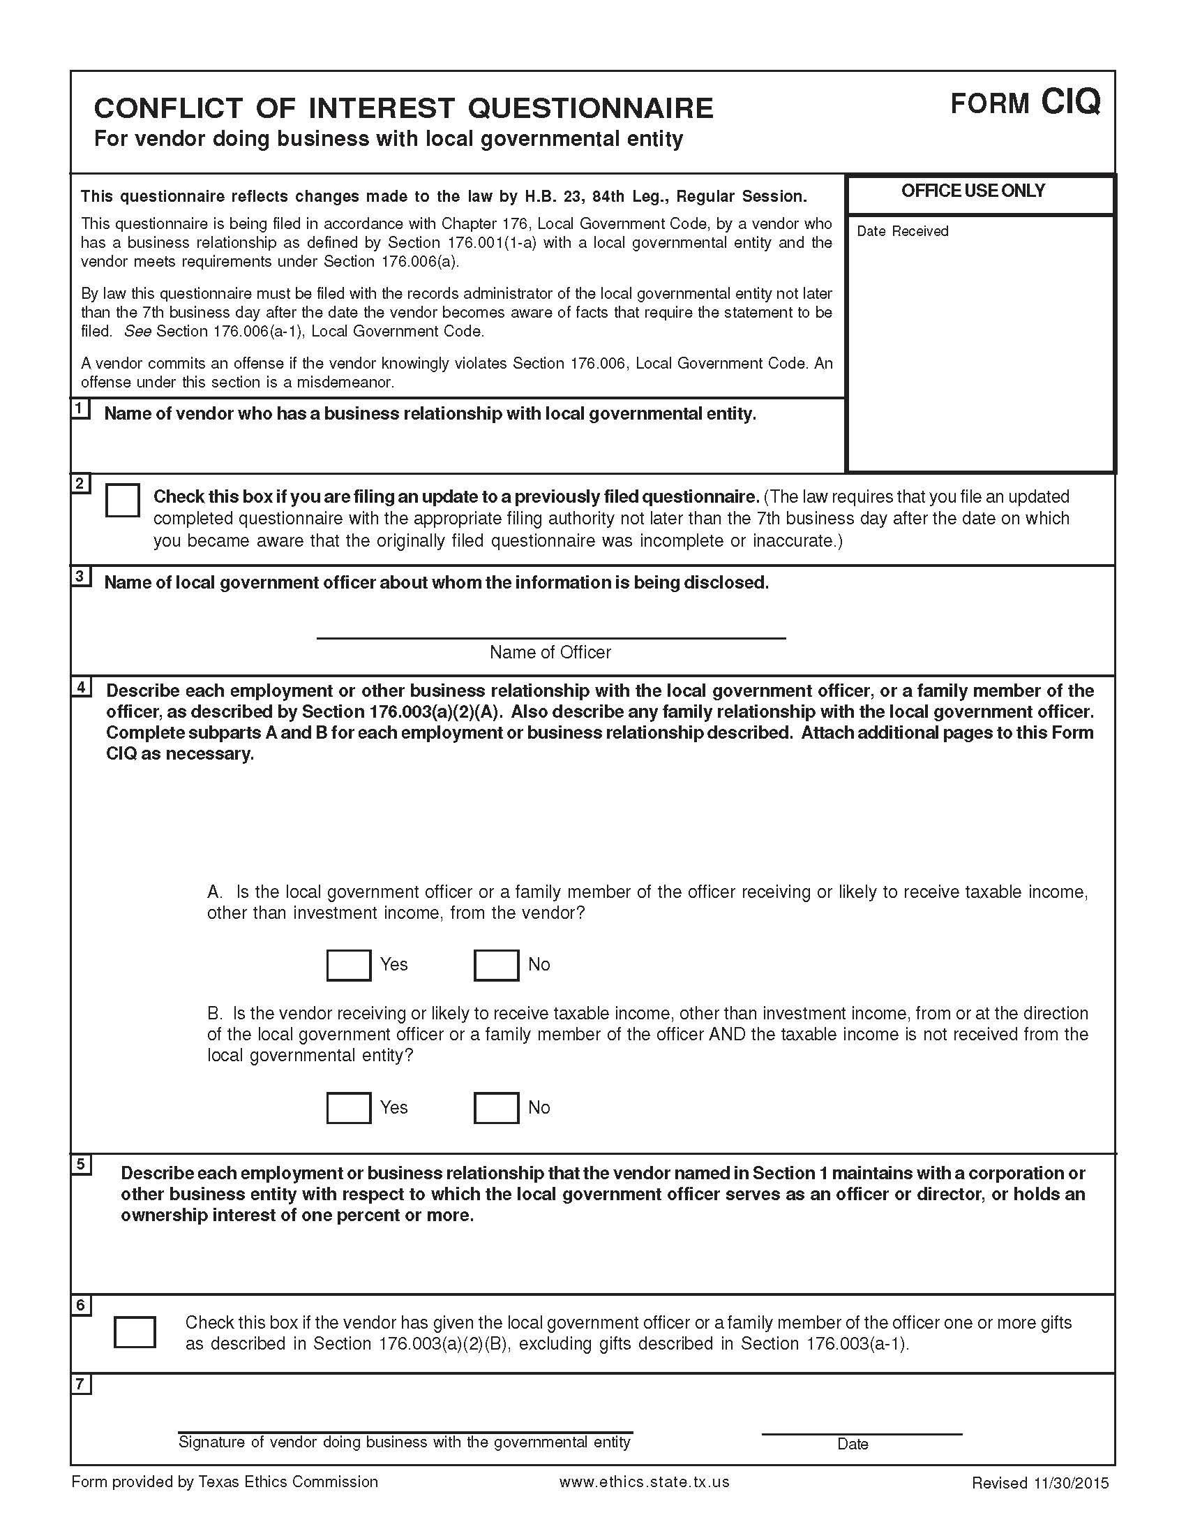

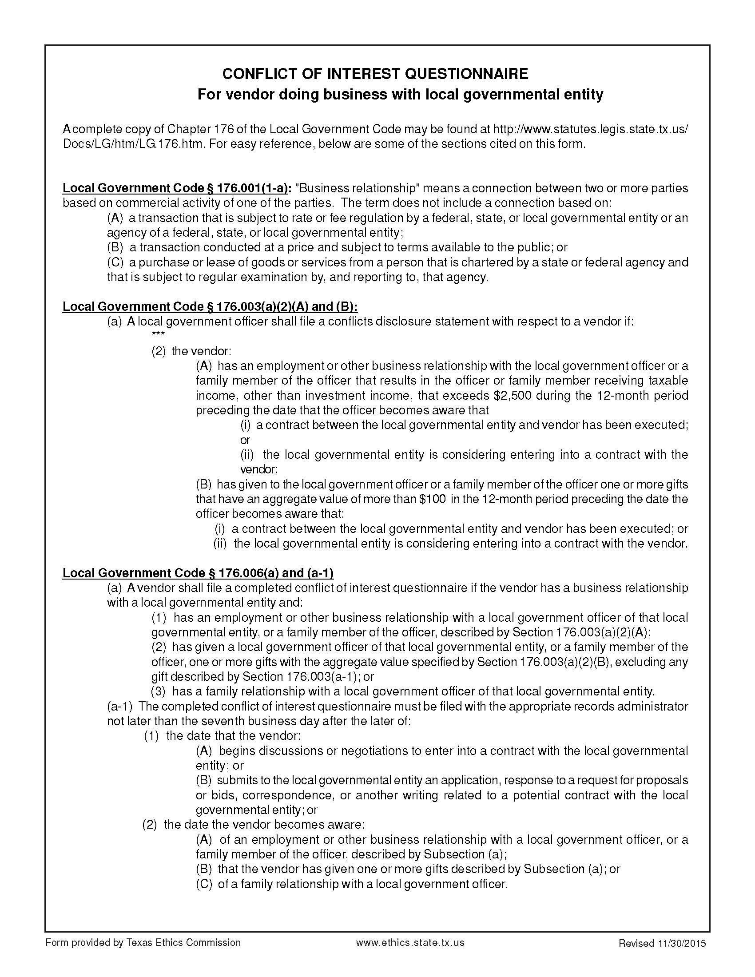

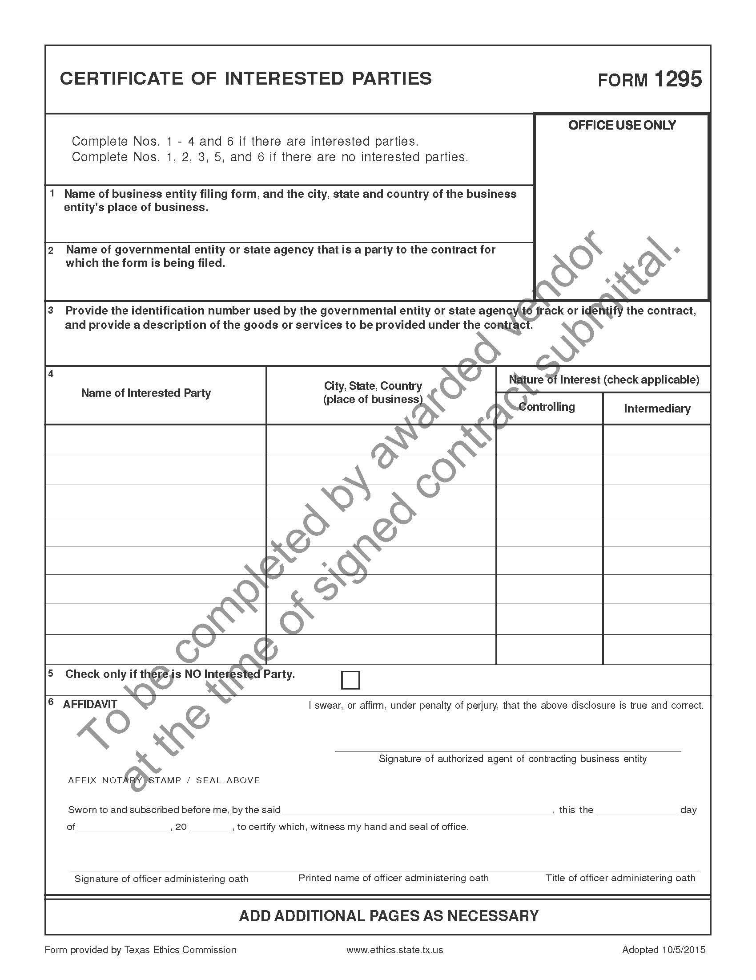

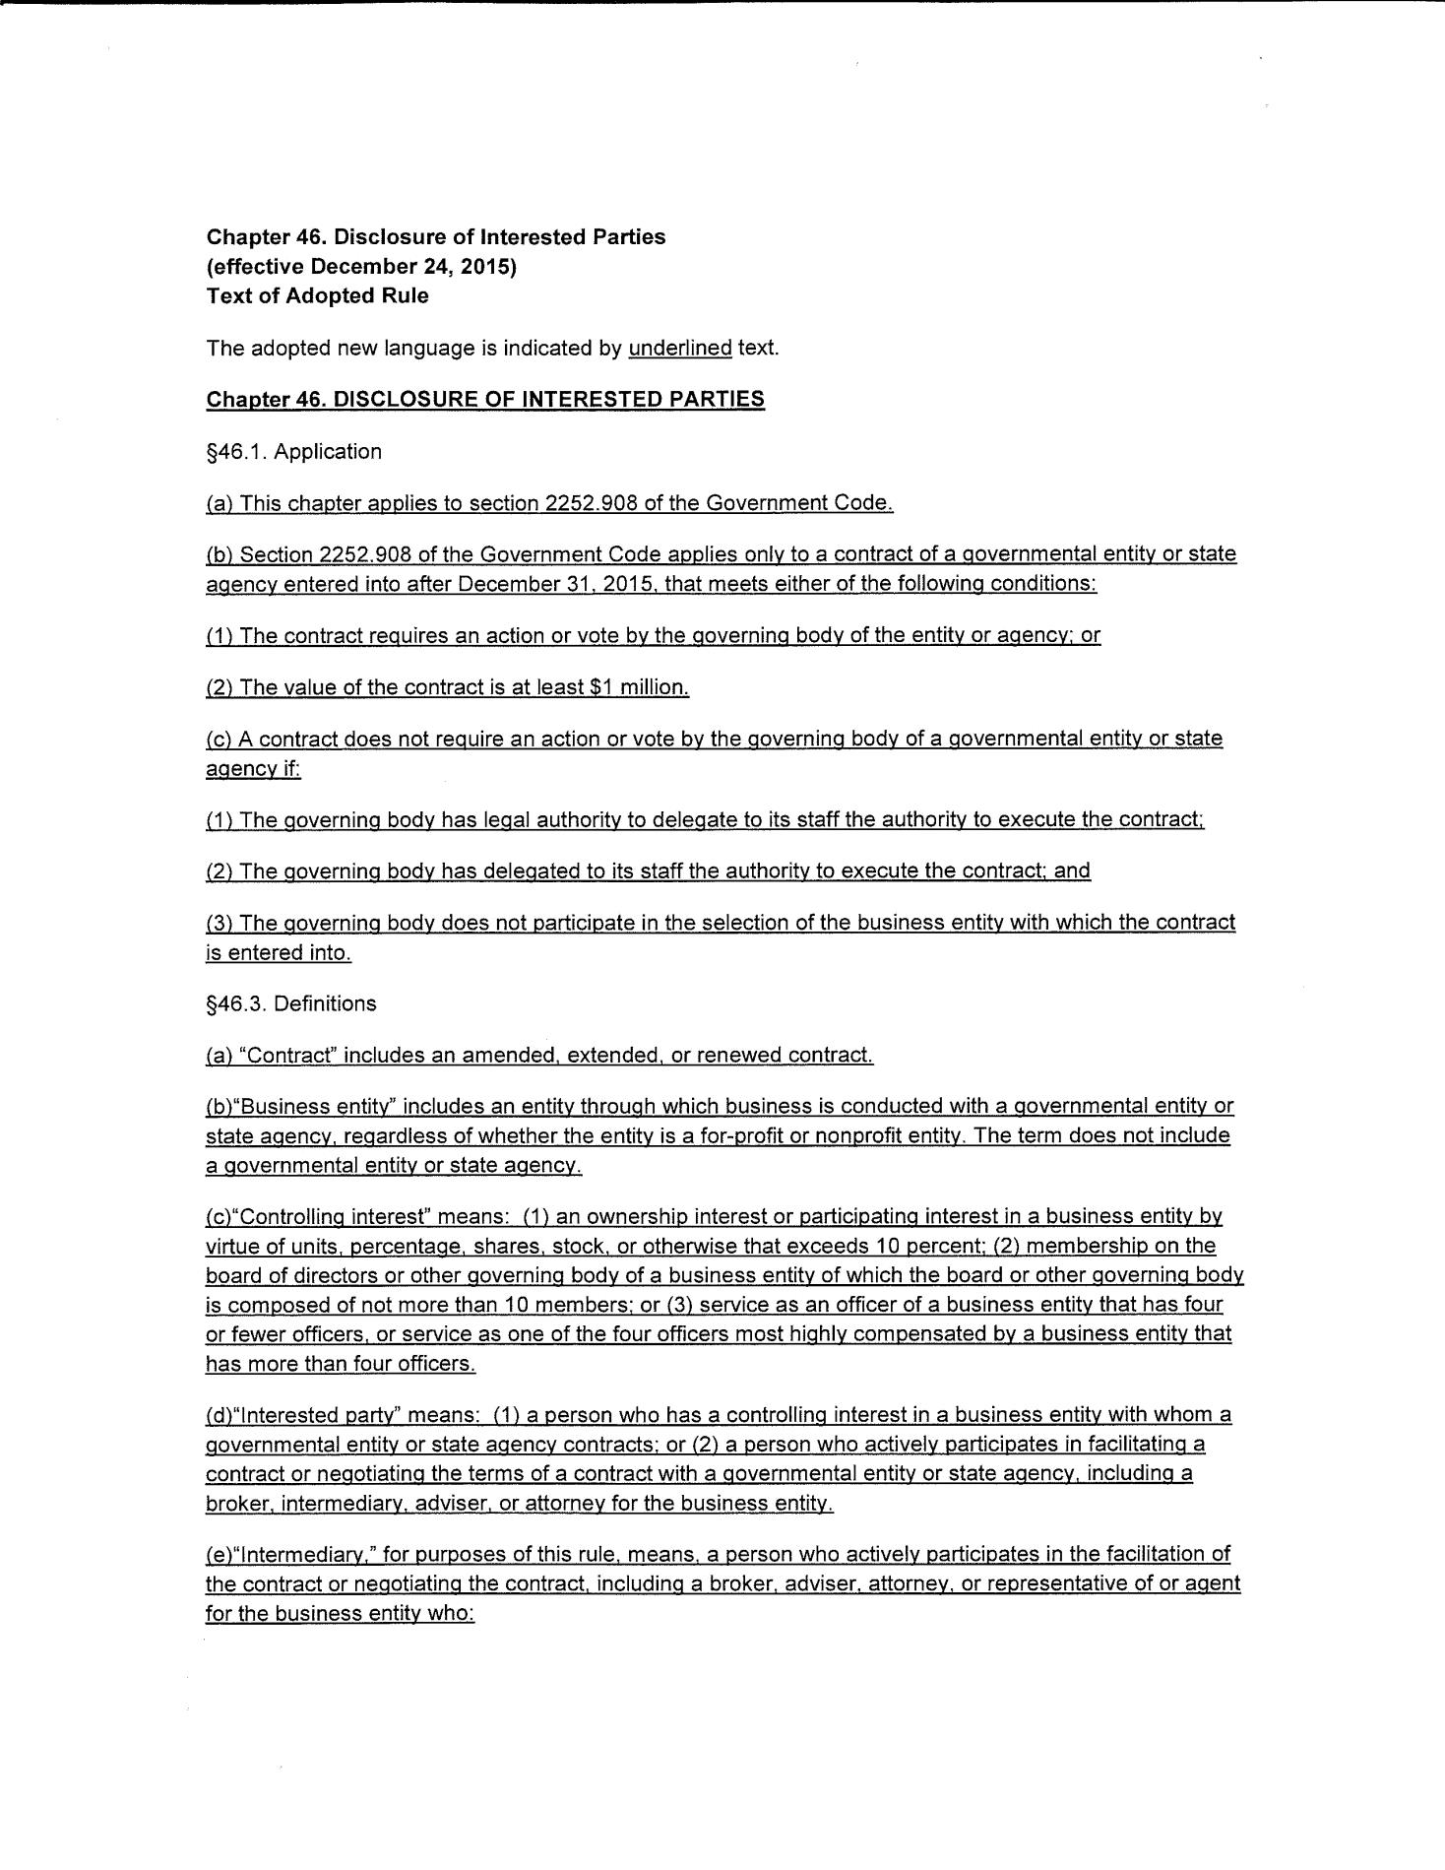

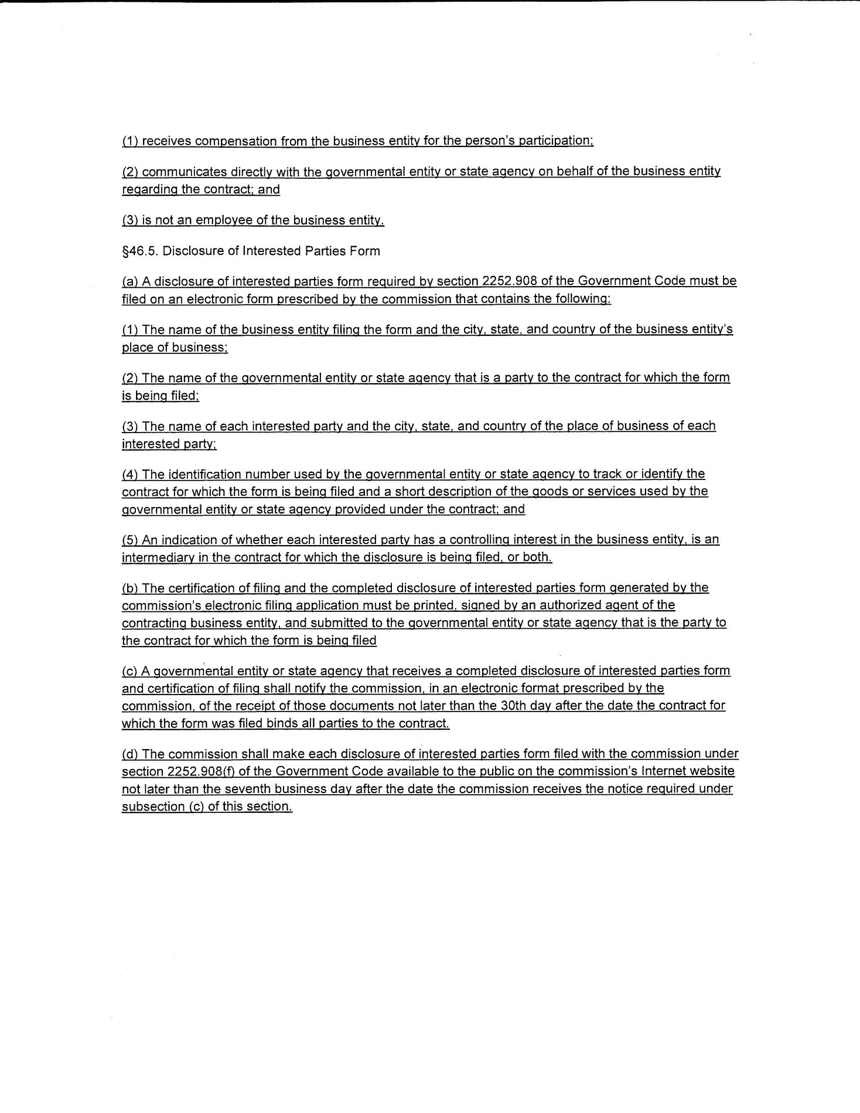

***VENDOR MUST PROVIDE APPLICABLE COMMODITY CODES IN ORDER TO BE CONSIDERED. ENGINEERING, ARCHITECTURAL, AND ENVIRONMENTAL SERVICES MUST ADD 2 DIGIT CODE TO 3 DIGIT CLASSIFICATION.
VENDOR NAME DATE FORM COMPLETED: SAM.GOV: VENDOR D & B DUNS NUMBER: CAGE CODE:
Is vendor incorporated? Yes No; If incorporated: How incorporated: Where incorporated:
Has Name Changed in past two (2) years? | ❑ | Yes | ❑ | No | If Yes, When
FORMER NAME
ORDER /PHYSICAL ADDRESS:
 |  |  |  |  |  | COUNTY
COMPLETE STREET ADDRESS (Cannot be P.O. Box) |  |  |  |  | CITY | STATE / ZIP
 |  |  |  | ( ) |  | ( )
SALES/PARTS CONTACT PERSON/TITLE |  |  |  | TELEPHONE # |  | FACSIMILE #
WEBSITE ADDRESS: |  |  |  | EMAIL ADDRESS:
REMIT ADDRESS:
REMITTANCE NAME (If different from above) |  |  |  |  |  | COUNTY
COMPLETE REMIT TO ADDRESS |  |  |  |  | CITY | STATE / ZIP
 |  |  |  | ( ) |  | ( )
CONTACT PERSON/TITLE  EMAIL ADDRESS |  |  |  | TELEPHONE # |  | FACSIMILE #
INVOICING ADDRESS (If different than Remit):
 |  |  |  |  |  | COUNTY
COMPLETE INVOICING ADDRESS |  |  |  |  | CITY | STATE / ZIP
 |  |  |  | ( ) |  | ( )
CONTACT PERSON/TITLE  EMAIL ADDRESS |  |  |  | TELEPHONE # |  | FACSIMILE #
PLEASE PROVIDE A GENERAL DESCRIPTION OF THE PRODUCTS OR SERVICES SOLD:
VENDOR’S COMMODITY CODES (3 DIGIT) **REQUIRED** |  |  |  |  |  | FOR INTERNAL USE ONLY
Entered into PeopleSoft by: Date: NEWTON CO. VENDOR #
DOCS SCANNED TO VENDOR SET-UP: YES _NO

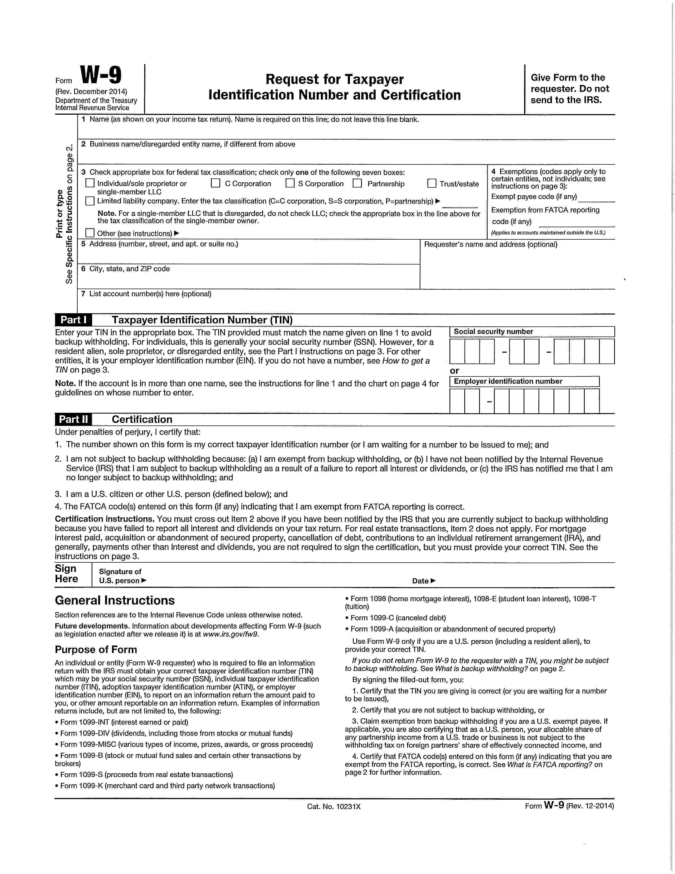

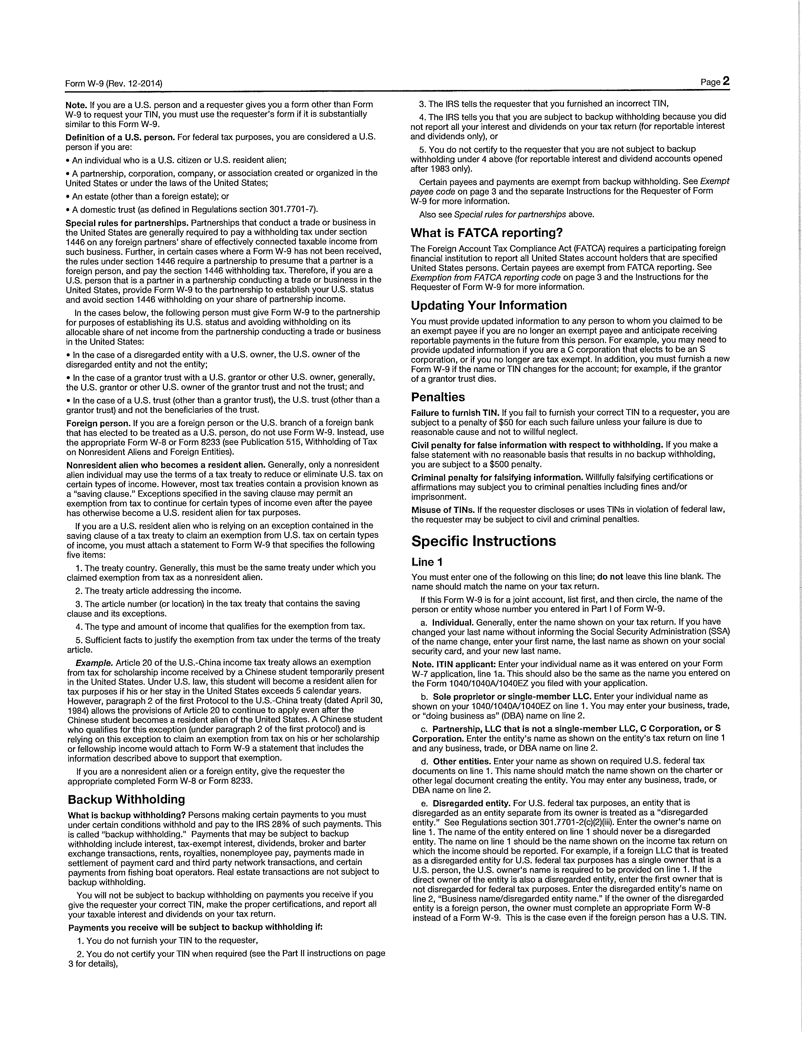

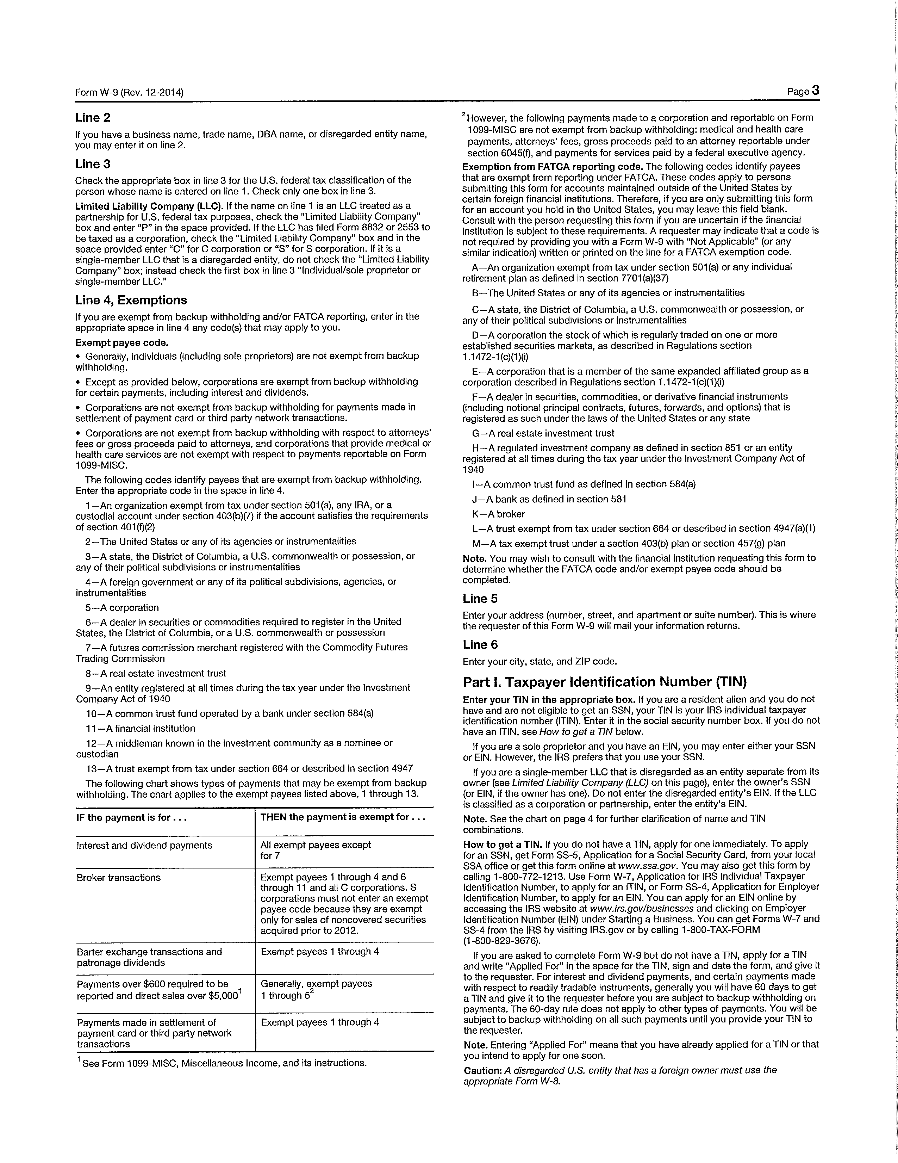

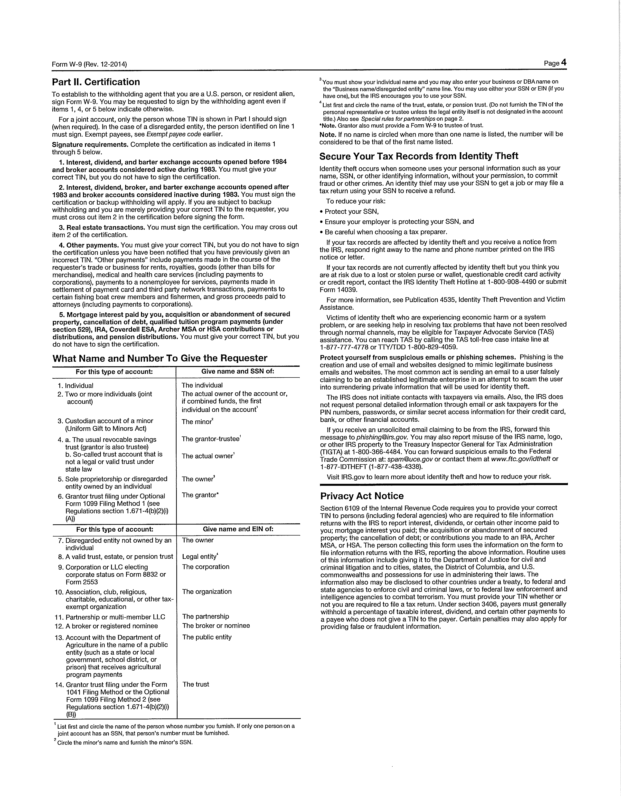

NEWTON COUNTY RETURN LABEL

*****LATE RESPONSES CANNOT BE ACCEPTED*****

REQUEST FOR PROPOSAL (RFP)
RFP#: | 2018-8
DUE DATE: | FRIDAY, NOVEMBER 9, 2018
TIME: | 4:30 P.M.. C.S.T.
RFP DESCRIPTION: | RFP#2018-8 TREC HOUSE INSPECTOR FOR CDBG DISASTER RECOVERY FUNDS (2015 AND 2016 FLOODING EVENTS/DR-4223, DR-4245, & DR-4266 DISASTER DECLARATIONS)
RETURN OFFER TO: PHYSICAL ADDRESS:
SANDRA K. DUCKWORTH
NEWTON COUNTY CLERK
115 COURT STREET
NEWTON, TX 75966
DATED MATERIAL – DELIVER IMMEDIATELY

PLEASE CUT OUT AND AFFIX THE RFP LABEL ABOVE TO THE OUTER MOST ENVELOPE OF YOUR RESPONSE TO HELP ENSURE PROPER DELIVERY!

**VENDOR MUST RETURN ONE (1) ORIGINAL AND FOUR (4) BOUND, COMPLETE COPIES OF THE BID DOCUMENTS**

*****LATE RFP’s CANNOT BE ACCEPTED*****

APPENDIX A

